**9. ReactJS-HOL**

**Create a React Application named “cricketapp” with the following components:**

1. ListofPlayers

* Declare an array with 11 players and store details of their names and scores using the map feature of ES6

**ListofPlayers.js :**

import React from 'react';

const ListofPlayers = () => {

  const players = [

    { name: 'Virat', score: 85 },

    { name: 'Rohit', score: 45 },

    { name: 'Rahul', score: 73 },

    { name: 'Shreyas', score: 97 },

    { name: 'Sai', score: 95 },

    { name: 'Jadeja', score: 25 },

    { name: 'Hardik', score: 70 },

    { name: 'Bumrah', score: 60 },

    { name: 'Shami', score: 67 },

    { name: 'Kuldeep', score: 45 },

    { name: 'Surya', score: 100 }

  ];

  const filteredPlayers = players.filter(player => player.score < 70);

  return (

    <div>

      <h2>All Players</h2>

      <ul>

        {players.map((player, index) => (

          <li key={index}>{player.name} - {player.score}</li>

        ))}

      </ul>

      <h2>Players with score less than 70</h2>

      <ul>

        {filteredPlayers.map((player, index) => (

          <li key={index}>{player.name} - {player.score}</li>

        ))}

      </ul>

    </div>

  );

};

export default ListofPlayers;

**IndianPlayers.js :**

import React from 'react';

const IndianPlayers = () => {

  const T20players = ['Virat', 'Rohit', 'Pant', 'Hardik'];

  const RanjiTrophyPlayers = ['Rahane', 'Pujara', 'Jadeja'];

  const allPlayers = [...T20players, ...RanjiTrophyPlayers];

  const oddTeam = allPlayers.filter((_, index) => index % 2 === 0);

  const evenTeam = allPlayers.filter((_, index) => index % 2 !== 0);

  return (

    <div>

      <h2>Merged Player List:</h2>

      <ul>

        {allPlayers.map((player, i) => <li key={i}>{player}</li>)}

      </ul>

      <h3>Odd Team</h3>

      <ul>{oddTeam.map((p, i) => <li key={i}>{p}</li>)}</ul>

      <h3>Even Team</h3>

      <ul>{evenTeam.map((p, i) => <li key={i}>{p}</li>)}</ul>

    </div>

  );

};

export default IndianPlayers;

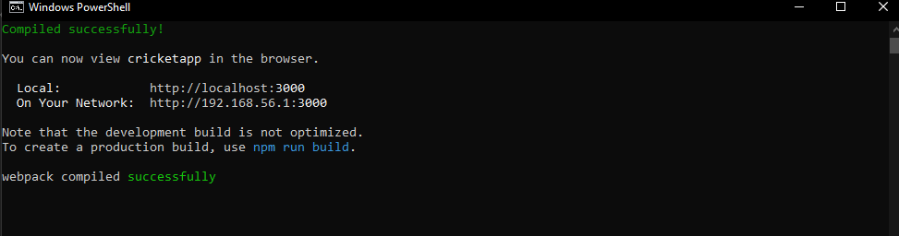

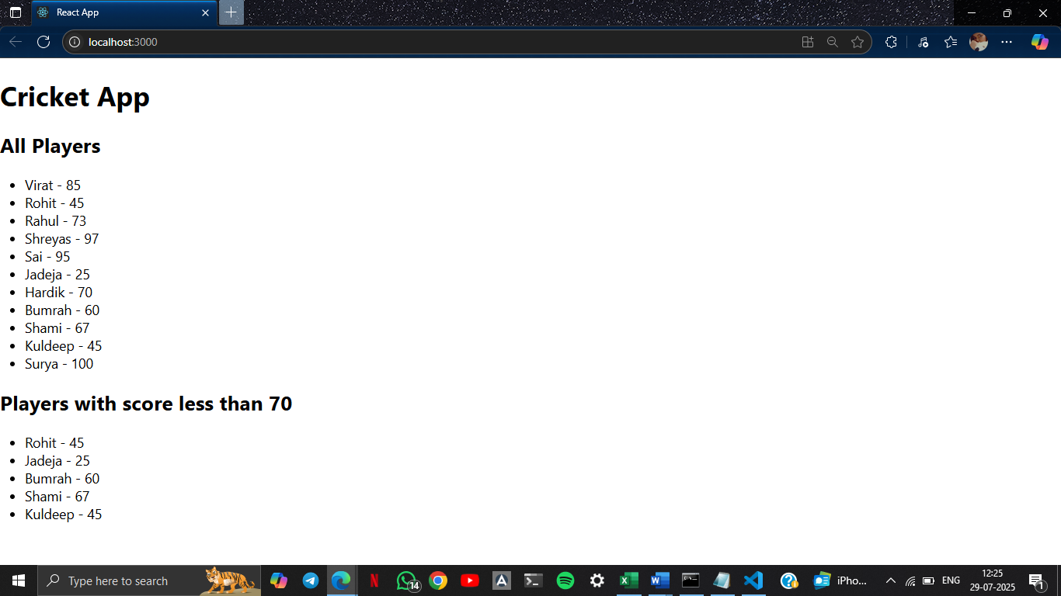

1. IndianPlayers
   1. Display the Odd Team Player and Even Team players using the Destructuring features of ES6

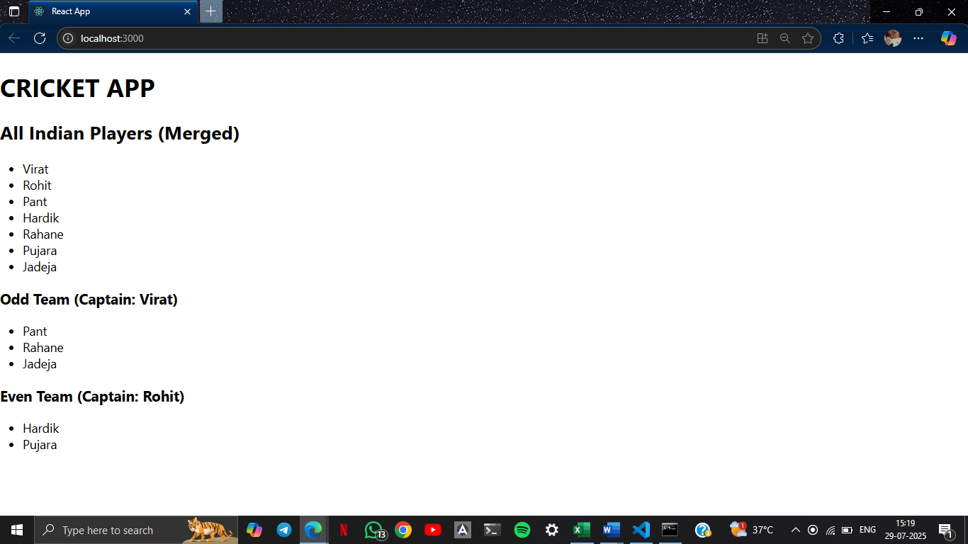

**10. ReactJS-HOL**

**Create a React Application named “officespacerentalapp” which uses React JSX to create elements, attributes and renders DOM to display the page.**

**App.js :**

import React from 'react';

function App() {

  const office = {

    Name: "DBS",

    Rent: 50000,

    Address: "Chennai",

    Image: "https://th.bing.com/th/id/R.436ca51e2b149e88d754c105ec0b3848?rik=Or8%2buRLPRmuJJg&riu=http%3a%2f%2fwww.virgobc.com%2fwp-content%2fuploads%2f2014%2f02%2fVirgo-Business-Centers-380-Lexington-Avenue-17th-Floor-New-York-NY-10168-212-601-2700-Furnished-Office-Space.jpg&ehk=QXUjb8j9NiFjRu8TKQkokrlchLw03V4EkbDU6hcB2dA%3d&risl=&pid=ImgRaw&r=0"

  };

  const rentStyle = {

    color: office.Rent <= 60000 ? "red" : "green"

  };

  const containerStyle = {

    padding: '20px',

    fontFamily: 'Arial',

    display: 'flex',

    flexDirection: 'column',

    alignItems: 'center',

    textAlign: 'center'

  };

  return (

    <div style={containerStyle}>

      <h1>Office Space , at Affordable Range</h1>

      <img src={office.Image} width="30%" alt="Office Space" />

      <h2><strong>Name:</strong> {office.Name}</h2>

      <h3 style={rentStyle}><strong>Rent: Rs. {office.Rent}</strong></h3>

      <h3><strong>Address:</strong> {office.Address}</h3>

    </div>

  );

}

export default App;

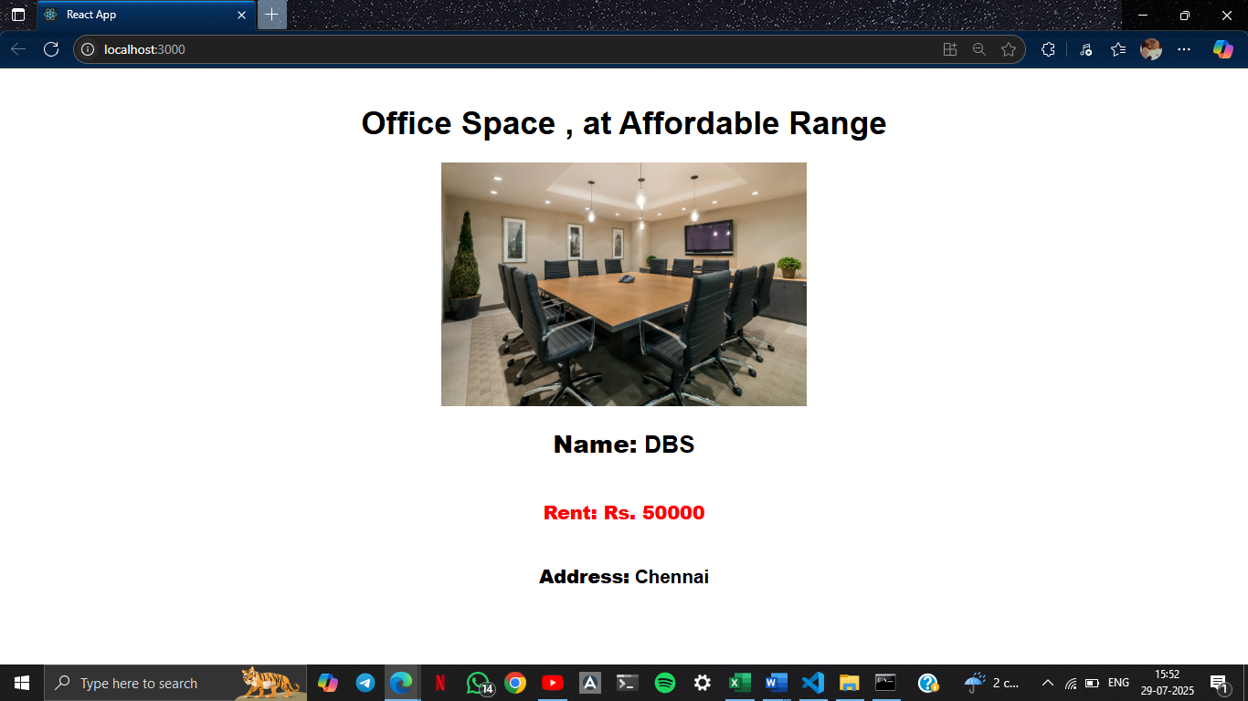

**11. ReactJS-HOL**

Create a React Application “eventexamplesapp” to handle various events of the form elements in HTML.

**Counter.js :**

import React, { Component } from 'react';

class Counter extends Component {

  constructor(props) {

    super(props);

    this.state = { count: 0 };

  }

  increment = () => {

    this.setState({ count: this.state.count + 1 }, this.sayHello);

  };

  decrement = () => {

    this.setState({ count: this.state.count - 1 });

  };

  sayHello = () => {

    alert("Hello! Number!!");

  };

  render() {

    return (

      <div>

        <h2>{this.state.count}</h2>

        <button onClick={this.increment}>Increment</button>

        <button onClick={this.decrement}>Decrement</button>

      </div>

    );

  }

}

export default Counter;

**CounterConvertor.js :**

import React, { useState } from 'react';

function CurrencyConverter() {

  const [rupees, setRupees] = useState('');

  const [converted, setConverted] = useState('');

  const [currencyType, setCurrencyType] = useState('Euro');

  const handleSubmit = (e) => {

    e.preventDefault();

    let rate = 0;

    if (currencyType === 'Euro') rate = 0.08;

    else if (currencyType === 'Dollar') rate = 0.012;

    else if (currencyType === 'Pound') rate = 0.009;

    const result = ((parseFloat(rupees) || 0) * rate).toFixed(2);

    alert(`Converting to ${currencyType} Amount is ${result}`);

    setConverted(`${currencyType}: ${result}`);

  };

  return (

    <div>

      <h2 style={{ color: 'green' }}>Currency Convertor!!!</h2>

      <form onSubmit={handleSubmit}>

        <label>Amount: </label>

        <input

          type="number"

          value={rupees}

          onChange={(e) => setRupees(e.target.value)}

        /><br /><br />

        <label>Currency: </label>

        <select value={currencyType} onChange={(e) => setCurrencyType(e.target.value)}>

          <option value="Euro">Euro</option>

          <option value="Dollar">Dollar</option>

          <option value="Pound">Pound</option>

        </select><br /><br />

        <input type="submit" value="Submit" /><br /><br />

        <label>Converted: </label>

        <input type="text" value={converted} readOnly />

      </form>

    </div>

  );

}

export default CurrencyConverter;

**SayWelcome.js :**

import React from 'react';

function SayWelcome() {

  const handleClick = () => {

    alert('Welcome!');

  };

  return (

    <div>

      <button onClick={handleClick}>Say Welcome</button>

    </div>

  );

}

export default SayWelcome;

**SyntheticEventExample.js :**

import React from 'react';

function SyntheticEventExample() {

  const handleClick = (e) => {

    alert('Clicked using Synthetic Event');

  };

  return (

    <div>

      <button onClick={handleClick}>Click on me</button>

    </div>

  );

}

export default SyntheticEventExample;

**App.js :**

import React from 'react';

import './App.css';

import Counter from './Counter';

import SayWelcome from './SayWelcome';

import SyntheticEventExample from './SyntheticEventExample';

import CurrencyConverter from './CurrencyConvertor';

function App() {

  return (

    <div className="App">

      <Counter />

      <SayWelcome />

      <SyntheticEventExample />

      <CurrencyConverter />

    </div>

  );

}

export default App;

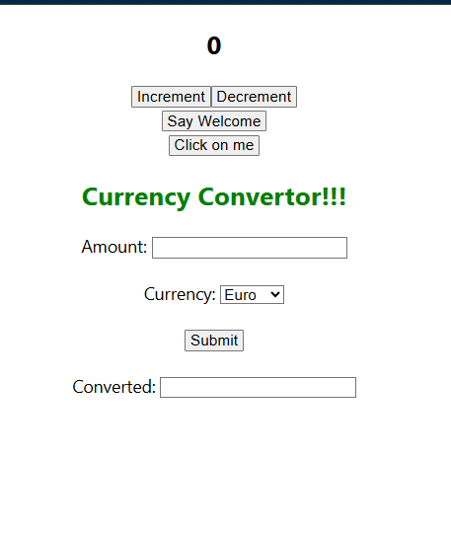

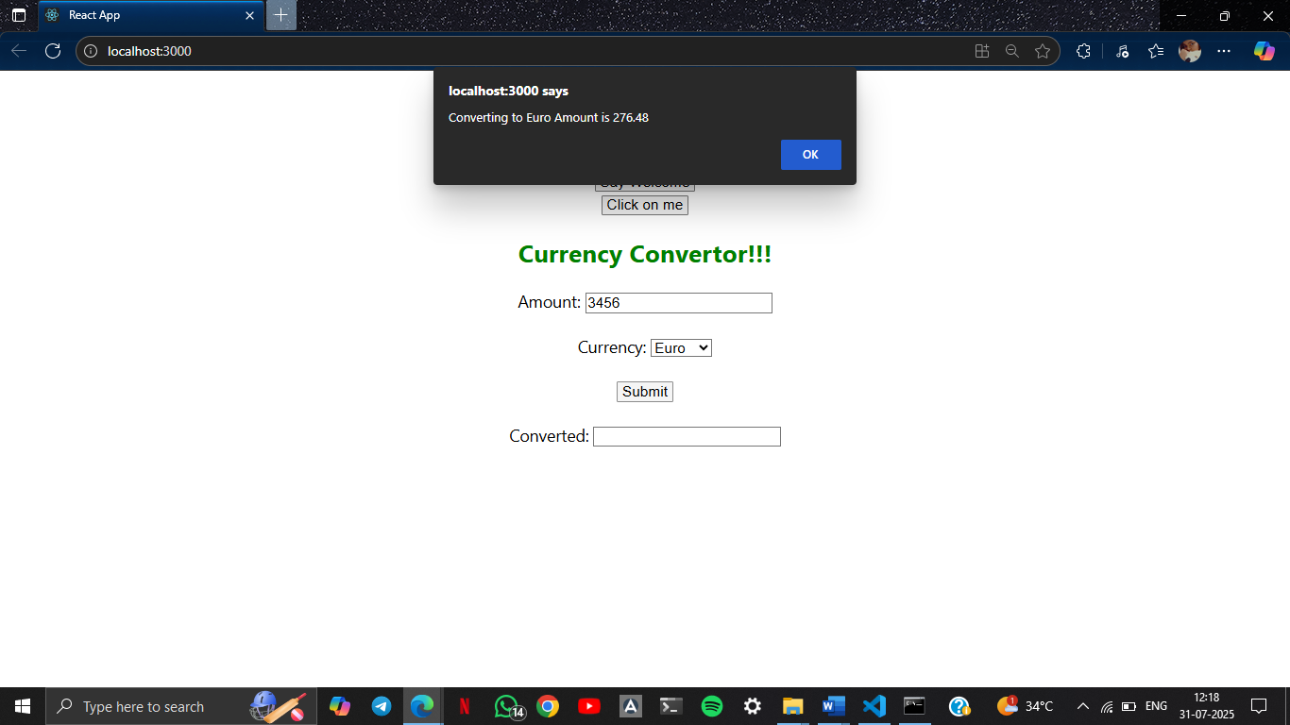

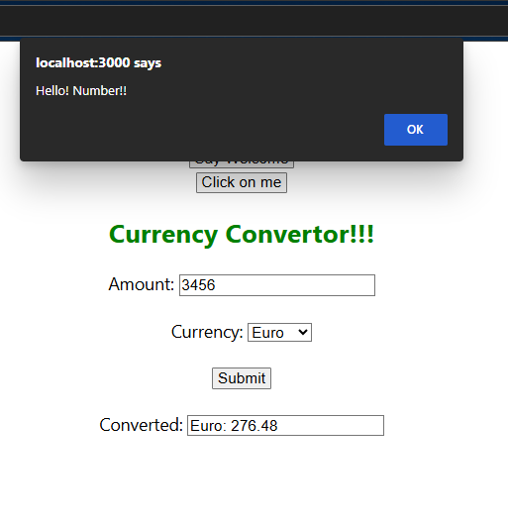

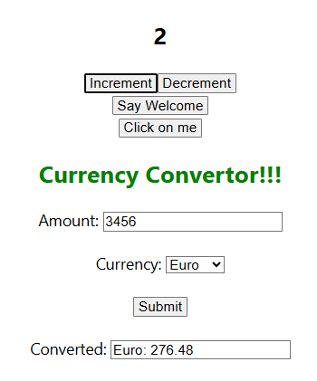

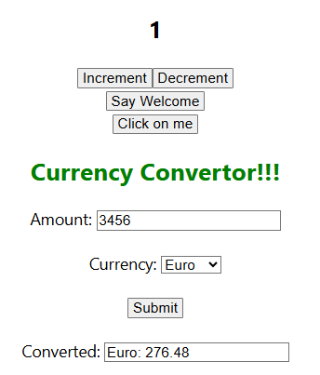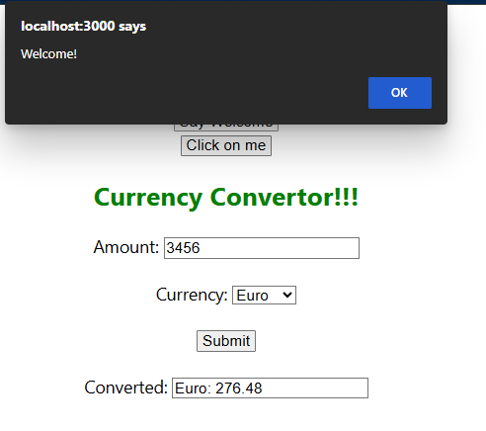

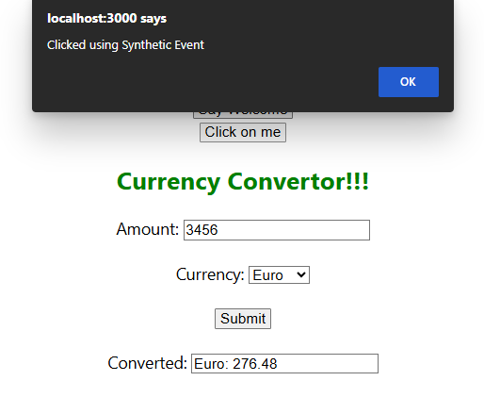

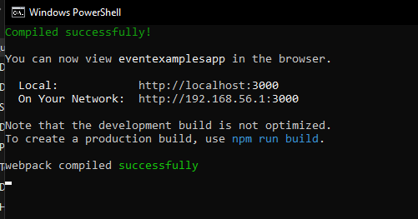

**12. ReactJS-HOL**

Create a React Application named “ticketbookingapp” where the guest user can browse the page where the flight details are displayed whereas the logged in user only can book tickets.

The Login and Logout buttons should accordingly display different pages. Once the user is logged in the User page should be displayed. When the user clicks on Logout, the Guest page should be displayed.

**App.js :**

import React, { useState } from 'react';

function LoginButton(props) {

  return (

    <button onClick={props.onClick}>

      Login

    </button>

  );

}

function LogoutButton(props) {

  return (

    <button onClick={props.onClick}>

      Logout

    </button>

  );

}

function GuestPage() {

  return <h2>Welcome Guest! You can browse flights.</h2>;

}

function UserPage() {

  return <h2>Welcome User! You can now book tickets.</h2>;

}

function Greeting(props) {

  const isLoggedIn = props.isLoggedIn;

  if (isLoggedIn) {

    return <UserPage />;

  }

  return <GuestPage />;

}

function App() {

  const [isLoggedIn, setIsLoggedIn] = useState(false);

  const handleLoginClick = () => {

    setIsLoggedIn(true);

  };

  const handleLogoutClick = () => {

    setIsLoggedIn(false);

  };

  let button;

  if (isLoggedIn) {

    button = <LogoutButton onClick={handleLogoutClick} />;

  } else {

    button = <LoginButton onClick={handleLoginClick} />;

  }

  return (

    <div className="App">

      <h1>Ticket Booking App</h1>

      {button}

      <Greeting isLoggedIn={isLoggedIn} />

    </div>

  );

}

export default App;

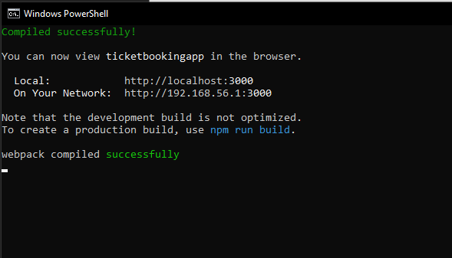

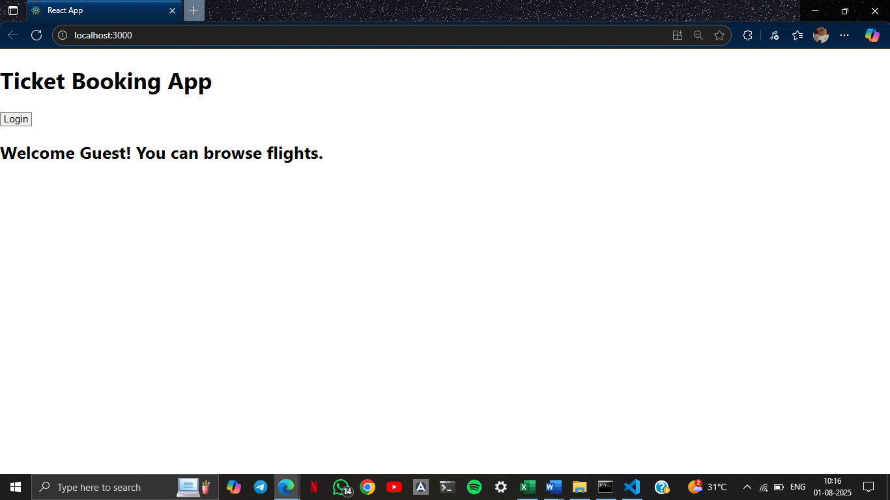

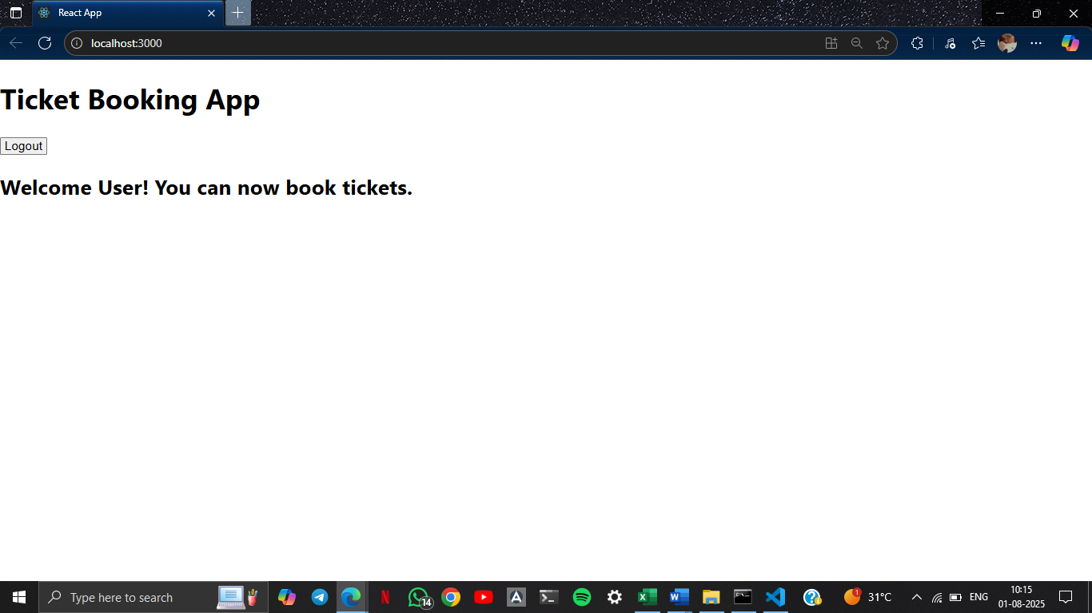

**13. ReactJS-HOL**

Create a React App named “bloggerapp” in with 3 components.

1. Book Details
2. Blog Details
3. Course Details

**BlogDetails.js :**

import React from 'react';

function BlogDetails({ blogs }) {

  return (

    <ul>

      {blogs.map((blog) => (

        <div key={blog.id}>

          <h3>{blog.title}</h3>

          <strong>{blog.author}</strong>

          <p>{blog.content}</p>

        </div>

      ))}

    </ul>

  );

}

export default BlogDetails;

**BookDetails.js :**

import React from 'react';

function BookDetails({ books }) {

  return (

    <ul>

      {books.map((book) => (

        <div key={book.id}>

          <h3>{book.bname}</h3>

          <h4>{book.price}</h4>

        </div>

      ))}

    </ul>

  );

}

export default BookDetails;

**CourseDetails.js :**

import React from 'react';

function CourseDetails({ courses }) {

  return (

    <ul>

      {courses.map((course) => (

        <div key={course.id}>

          <h3>{course.name}</h3>

          <p>{course.date}</p>

        </div>

      ))}

    </ul>

  );

}

export default CourseDetails;

**data.js :**

export const books = [

  { id: 101, bname: 'Master React', price: 670 },

  { id: 102, bname: 'Deep Dive into Angular 11', price: 800 },

  { id: 103, bname: 'Mongo Essentials', price: 450 },

];

export const blogs = [

  { id: 1, title: 'React Learning', author: 'Stephen Biz', content: 'Welcome to learning React!' },

  { id: 2, title: 'Installation', author: 'Schwedzneier', content: 'You can install React from npm.' },

];

export const courses = [

  { id: 1, name: 'Angular', date: '4/5/2021' },

  { id: 2, name: 'React', date: '6/3/2021' },

];

**App.css :**

.App {

  text-align: center;

}

.content-container {

  display: flex;

  justify-content: space-around;

  margin-top: 20px;

}

.st2, .v1, .mystyle1 {

  border-right: 10px solid rgb(5, 87, 5);

  padding: 10px;

}

.buttons button {

  margin: 10px;

  padding: 8px 16px;

  font-weight: bold;

  cursor: pointer;

}

**App.js :**

import React, { useState } from 'react';

import './App.css';

import BookDetails from './components/BookDetails';

import BlogDetails from './components/BlogDetails';

import CourseDetails from './components/CourseDetails';

import { books, blogs, courses } from './data';

function App() {

  const [showBooks, setShowBooks] = useState(true);

  const [showBlogs, setShowBlogs] = useState(true);

  const [showCourses, setShowCourses] = useState(true);

  return (

    <div className="App">

      <h1>Blogger App</h1>

      <div className="buttons">

        <button onClick={() => setShowBooks(!showBooks)}>Toggle Books</button>

        <button onClick={() => setShowBlogs(!showBlogs)}>Toggle Blogs</button>

        <button onClick={() => setShowCourses(!showCourses)}>Toggle Courses</button>

      </div>

      <div className="content-container">

        {showCourses && (

          <div className="mystyle1">

            <h1>Course Details</h1>

            <CourseDetails courses={courses} />

          </div>

        )}

        {showBooks && (

          <div className="st2">

            <h1>Book Details</h1>

            <BookDetails books={books} />

          </div>

        )}

        {showBlogs ? (

          <div className="v1">

            <h1>Blog Details</h1>

            <BlogDetails blogs={blogs} />

          </div>

        ) : null}

      </div>

    </div>

  );

}

export default App;

